CIRCUTAL DILEEMA FINAL ROUND QUESTIONS (2ND YEARS AND 3RD YEARS)

1Q:

Depending on the user's preferences, sound may be played back on mobile phones in four distinct ways. The sound output comes from the earphones if the user plugs in a jack pin (earphones). The sound originates from Bluetooth when the user connects it. The mobile phone's speaker is used for output when no Bluetooth or ear buds are connected. The mobile phone's internal speaker produces sound when the user is speaking on a phone call. Hence, logic circuits are built into mobile phones to emit sound based on the user?

QUESTION:

For such phones, create a logic circuit utilizing simply a 2X1 multiplexer. You must provide the logic diagram together with the truth tables for the input (in the form of an external speaker, an internal speaker, a Bluetooth device, or an earphone), output, and a few more inputs. Moreover, you must update your previous diagram using just the logic gates listed below: AND, OR, OR NOT.

2Q:

You can access the magical room by using the key ABCD at the entrance. The series of ones and zeros in this key represent a valid XS3 code. On the wall close by, there are a few hints scribbled in magic ink. (S0, S1<=AB)

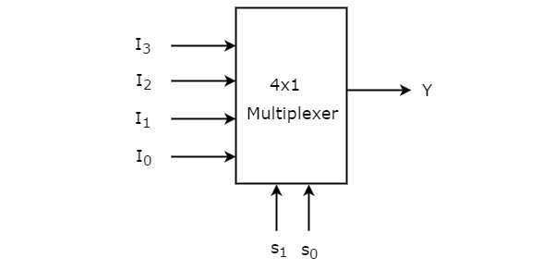

The key port is enchanted in a way that it accepts only the case of I which has the least cost of implementation.

I3 = (x xor(x xor y))+(z'xy+yz+zx')

I2 = (x xnor(x xnor y))+(z xor(x xor z))

I1 = (x xnor(x xor y))+(zy+(yx+zx)'+yz)

I0 = (x xor(x xnor y))+z’

3Q:

The circuit diagram of the transmitter is shown below. You have to fill the blank space with the logic gates for making a 7-bit humming code as an output.

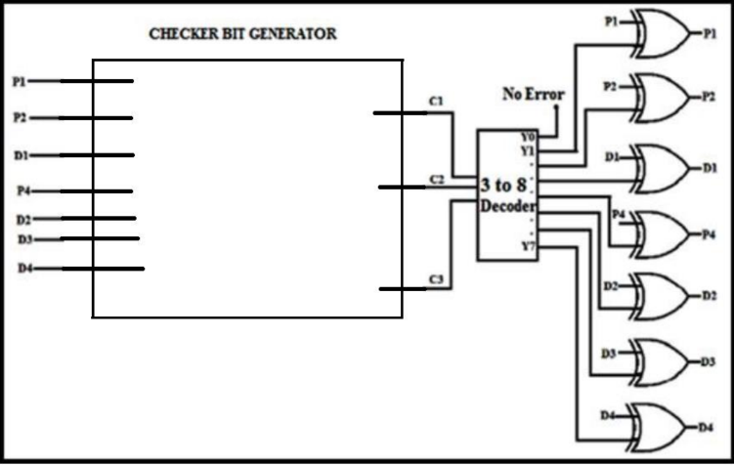

4Q:

All the logic gates shown in the figure have a propagation delay of 20 ns. Let A = C =0 and B = 1 until time t = 0. At t =0, all the inputs flip (i.e. A = C = 1 and B = 0) and remain in that state. For t> 0, output Z = 1 for a duration (In ns) of

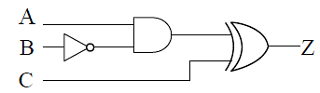

Q5.

A three bit pseudo random number generator is shown. Initially the value of the output Y= $Y_{2}Y_{1}Y_{0}$ is set to 111.The value of output Y after three clock cycles is

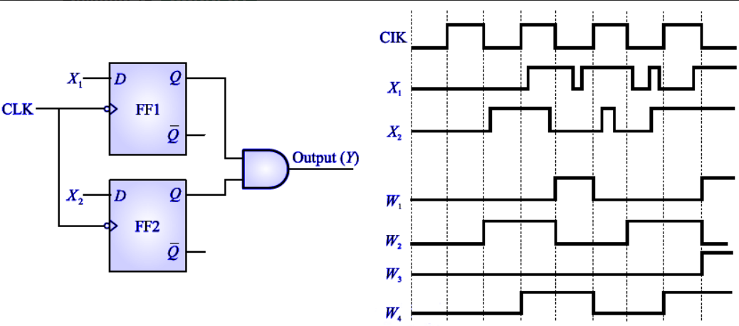

**Q6.** 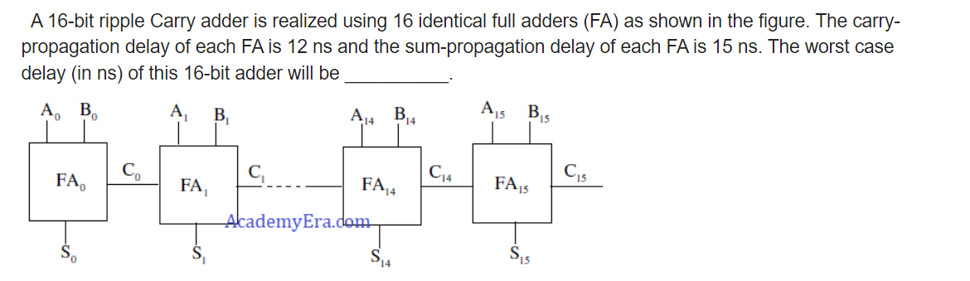

7Q:

A new filp-flop is having behavior as stated below: The inputs of the flip-flop are A and B.

If both inputs are same i.e. (1,1) the condition of the flip-flop is set else reset.

If both inputs are different i.e. 0, 1 flip-flop complements itself in other case it will retain to the previous state. Obtain a characteristic expression for new flip-flop?

8Q:

Ramu had a computer, He knows that a register to accept, store and transfer data. Ramu saw a figure where a shift register content is loaded with 1010. Then Ramu had a doubt that when clock is applied continuously on shift register after how many clock pulses content becomes 1010?

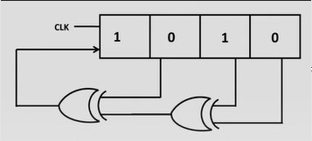

9Q:

Ramya wants to find the average power dissipated in the resistor R. She has designed a digital circuit where all gates were similar with resistor of 10K ohm and voltage of 5V. She designed a D-flip-flop mentioned it as D4, D3, D2, D1 and D0 and gave their logic values as 0, 1, 0,1,0. The duty cycle was 30%? Kindly help her in finding the average power?

